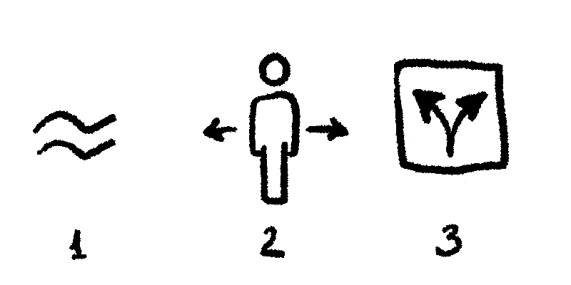

Concept for FUD

Secret group name is
Monsters and Gods

Federal bureau of immersion
Monsters and gods in logo

